Project 2 – VPN Testing
IFSM 370 6382 Telecommunications in Information Systems
University of Maryland University College

- VPN Log filled in completely
The log below shows the details of each time I used the VPN Client Tunnel Bear. I used this client while visiting 10 different websites, and “tunneling” or connecting via 10 different countries. I downloaded the software on my MacBook as well as my iPhone. Each time I visited a different site I took notes on my observations of speed, language and anything that distinctly caught my attention.

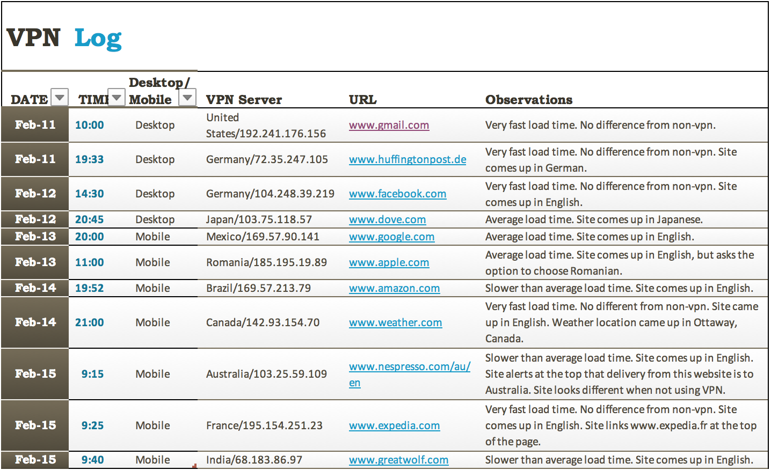
- Multiple VPN Servers
While testing this VPN client, I changed the VPN server each time to test 10 different countries. The countries that I tested were: The United States, Germany, Japan, Mexico, Romania, Brazil, Canada, Australia, France, and India. While there were some differences in speed, they were not significant. I connected to servers in Germany on two separate occasions. I wanted to see if the IP address would stay the same. The second time the VPN IP address did change.

- Document-General Experience
During this test, I installed the VPN client Tunnel Bear on my MacBook and iPhone. I was able to use the free trial download, and the installation was simple on both devices. As advertised, Tunnel Bear is an easy-to-use VPN for everyone. The Tunnel Bear site provides good information and FAQs to get started. At first, I did not know how to find the VPN’s IP address via the Tunnel Bear site or the app. I was able to find this via google, and the solution is to visit bearsmyip.com.

- Write up-Specifics
During each individual test, I compared the VPN performance to the speed one would experience if a user were not using a VPN client. Many of the tests performed so well, it was as if a VPN was not used at all. The countries that performed this well were the United States, Germany, Canada and France. Navigating through these sites while using Tunnel Bear was no different, and no issues were encountered. When I visited the sites in Germany they loaded in German and one address ended in .de instead of .com. The site I visited via the France server loaded in English, but also linked www.expedia.fr at the top of the page. The slowest countries were Brazil, Australia and India. While these were considered the slowest, that determination is relative to the others and I only experienced a slight lag in the beginning. The last three countries, Japan, Mexico and Romania performed at an average speed just slower than the “very fast” sites. When visiting sites via the Japan and Mexico server, both loaded in their respective languages. The site I visited via the Romania server loaded in English but gave the option for Romanian. Overall, I think the VPN client performed well via from each location. I thought it was interesting that the different servers presented websites in the languages of the countries where the servers resided and showed different products and information.

- VPN Benefits
The main benefit of using a VPN client like Tunnel Bear is to protect your online privacy. You can be anonymous, and the VPN will prevent people from spying on your internet use (Paul, 2017). It also prevents people from hacking into your network. I think this is extremely helpful if you need to use an unprotected and public wireless network, like in a café or public place. I can see myself using this VPN client in times like this to protect myself, but I probably would not use one from my home network because I have more control over my own network. I can secure it with a firewall, as well as with WPA or WPA2 router encryption (Waring, 2007). I can also turn off the SSID so that others cannot see it when their phones or computers are searching.

Conclusion
In conclusion, there are many benefits of using a VPN client like Tunnel Bear anytime you are accessing the internet. The VPN client will provide a level of protection that is especially important when using public networks. In my opinion, it may not be necessary to use a VPN client while accessing the internet at home, because I would be using my own private network with other encryptions in place. I think that this decision is subjective and should be based on each individual’s own personal opinions.

References

Paul, I. (2017, July 06). How-and why-you should use a VPN any time you hop on the internet. Retrieved from https://www.techhive.com/article/3158192/privacy/howand-whyyou-should-use-a-vpn-any-time-you-hop-on-the-internet.html
TunnelBear. (2019). TunnelBear: Secure VPN Service. Retrieved from https://www.tunnelbear.com/
Waring, B. (2007, April 09). How to Secure Your Wireless Network. Retrieved from https://www.pcworld.com/article/130330/article.html

